#setting home directory
getwd()
list.files()
setwd("C:/Users/USER/Downloads/R & Python")

##problem with source
.libPaths()
.libPaths("C:/Users/USER/Downloads/R & Python/pakage")

install.packages("ggplot2")
library(ggplot2)

# Load dataset
flight <- read.csv("C:/Users/USER/Downloads/R & Python/flight_data.csv")

# Random sample using student ID
set.seed(66)
flight_sample <- flight[sample(nrow(flight), 10000), ]
##Question 1 :What do coach ticket prices look like? What are the high and low values? What would be consideredthe average? Does $500 seem like a good price for a coach ticket?”
Solution:
# Summary statistics
summary(flight_sample$coach_price)
Output
Min. 1st Qu. Median Mean 3rd Qu.
84.5 331.3 380.3 376.0 426.4
Max.
586.0

# Mean
mean(flight_sample$coach_price)
Output
[1] 375.989

# Histogram
ggplot(flight_sample, aes(x=coach_price)) +
geom_histogram(bins=30, fill="skyblue", color="black") +
labs(
title="Distribution of Coach Ticket Prices",
x="Coach Ticket Price",
y="Frequency"
)
Output
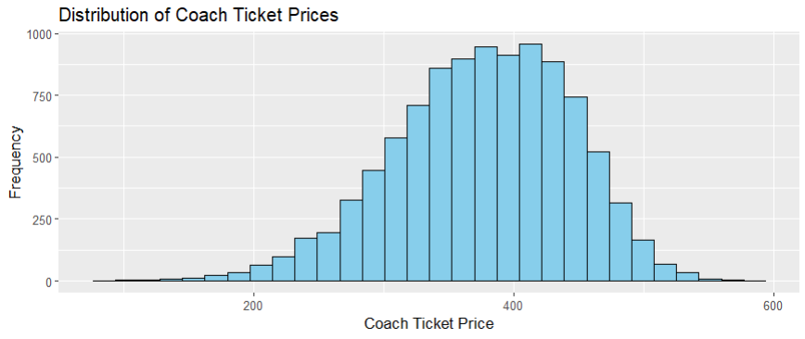
Interpretation
The histogram and summary statistics show the overall distribution of coach ticket prices. The average price can be compared with $500 to determine whether it is considered expensive or reasonable.
#Boxplot
boxplot(flight_sample$coach_price,
main = "Boxplot of Coach Ticket Price",
ylab = "Coach Ticket Price",
col = "red",
border = "black")

Output
library(ggplot2) library(ggplot2)
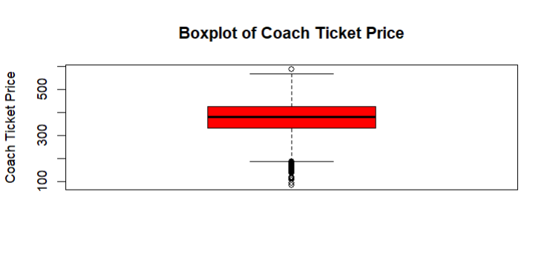
##Q2: What are the coach prices for flights that are 8 hours long? Does a $500 ticket seem more reasonable for these flights?
Solution:
#8-hour flights
flight_8 <- subset(flight_sample, hours == 8)

# Summary statistics
summary(flight_8$coach_price)
Output
Min. 1st Qu. Median Mean 3rd Qu.
213.0 383.1 426.2 426.8 477.4
Max.
568.5

Interpretation :
Long-duration flights generally have higher ticket prices. Therefore, a $500 coach ticket may be more acceptable for 8-hour flights.
##Q3: What does the distribution of flight delays look like? Are there any outliers?
Solution:
library(ggplot2)
# Histogram
ggplot(flight_sample, aes(x=delay)) +
geom_histogram(bins=40, fill="orange", color="black") +
labs(
title="Distribution of Flight Delays",
x="Delay Time",
y="Frequency"
)
Output
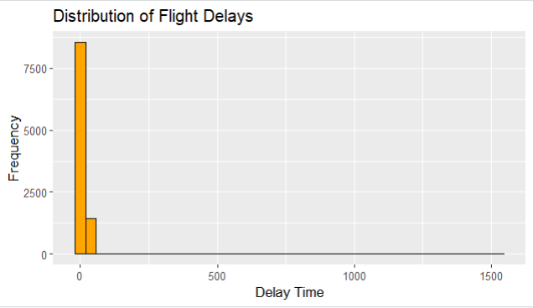

# Summary
summary(flight_sample$delay)
Output
Min. 1st Qu. Median Mean 3rd Qu.
0.00 9.00 10.00 13.29 13.00
Max.
1528.00

Interpretation :
Thedelaydistributionmaycontainoutliersduetoextremedelaysexperiencedbysome flights.

##Q4: How are coach ticket prices related to flight distance (miles)?
Solution:
library(ggplot2)
# Scatter plot
ggplot(flight_sample,
aes(x=miles, y=coach_price)) +
geom_point(alpha=0.3) +
labs(
title="Coach Price vs Flight Distance",
x="Miles",
y="Coach Price"
)
Output
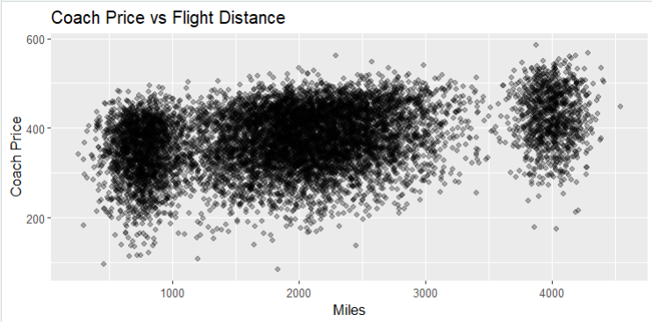

# Correlation
cor(flight_sample$miles,
flight_sample$coach_price)
Interpretation Thereisusuallyapositiverelationshipbetweenflightdistanceandticketprice.

##Q5: How are flight hours related to coach ticket prices?
Solution:
library(ggplot2)
# Scatter plot
ggplot(flight_sample,
aes(x=hours, y=coach_price)) +
geom_point(alpha=0.3) +
labs(
title="Flight Hours vs Coach Price",
x="Flight Hours",
y="Coach Price"
)
Output
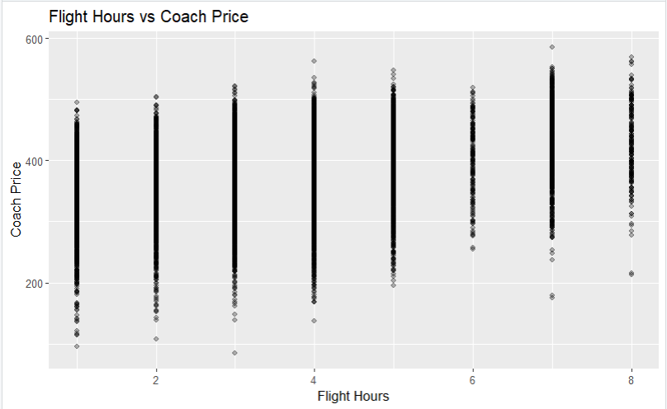

# Correlation
cor(flight_sample$hours,
flight_sample$coach_price)
Output
[1] 0.3371431

Interpretation
Longerflightdurationtendstoincreasecoachticketprices.

##Q6: How are coach ticket prices related to first-class ticket prices?
Solution:
library(ggplot2)
# Scatter plot
ggplot(flight_sample,
aes(x=coach_price,
y=firstclass_price)) +
geom_point(alpha=0.3) +
labs(
title="Coach vs First-Class Prices",
x="Coach Price",
y="First-Class Price"
)
Output
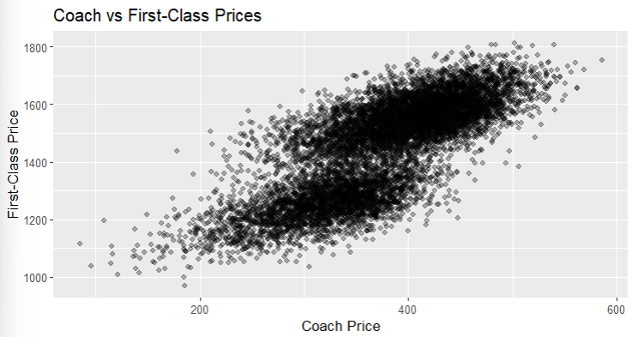

# Correlation
cor(flight_sample$coach_price,
flight_sample$firstclass_price)
Output
<[1] 0.7625297 (strong possitive) >

Interpretation
Highercoachpricesaregenerallyassociatedwithhigherfirst-classprices

##Q7: How do in-flight features affect coach ticket prices?
Solution:
# Meal
aggregate(coach_price ~ inflight_meal,
data=flight_sample,
mean)
Output
<inflight_meal coach_price
1 No 369.4530
2 Yes 390.9813>

# Entertainment
aggregate(coach_price ~ inflight_entertainment,
data=flight_sample,
mean)
Output
inflight_entertainment coach_price
1 No 319.6572
2 Yes 389.5651

# Wifi
aggregate(coach_price ~ inflight_wifi,
data=flight_sample,
mean)
Output
inflight_wifi coach_price
1 No 311.4042
2 Yes 383.3489

Interpretation Flightswithadditionalservicessuchasmeals,entertainment,andWiFioftenhavehigher ticketprices

##Q8: How do weekend flights compare to weekday flights in terms of ticket prices?
Solution:
library(ggplot2)
install.packages("dplyr")
library(dplyr)
# Average prices
weekend_price <- flight_sample %>%
group_by(weekend) %>%
summarise(
avg_coach = mean(coach_price),
avg_firstclass = mean(firstclass_price)
)
print(weekend_price)
Output
# A tibble: 2 × 3
weekend avg_coach avg_firstclass
<chr> <dbl> <dbl>
1 No 321. 1259.
2 Yes 406. 1559.

# Bar plot
ggplot(weekend_price,
aes(x=weekend,
y=avg_coach,
fill=weekend)) +
geom_bar(stat="identity") +
labs(
title="Weekend vs Weekday Coach Prices",
x="Weekend",
y="Average Coach Price"
)
Output
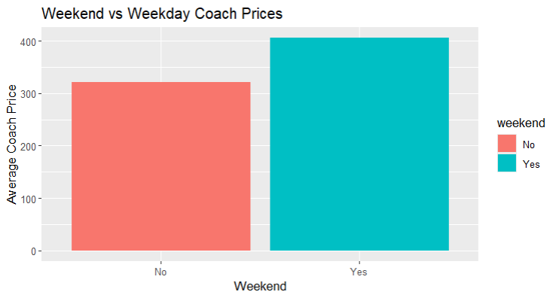
Interpretation
Weekend ticket prices may differ from weekday prices depending on passenger demand

##Q9: How do redeye flights compare to non-redeye flights in terms of coach ticket prices?
Solution :
library(ggplot2)
library(dplyr)
# Average prices
redeye_price <- flight_sample %>%
group_by(redeye) %>%
summarise(
avg_coach = mean(coach_price)
)
print(redeye_price)
Output
# A tibble: 2 × 2
redeye avg_coach
<chr> <dbl>
1 No 379.
2 Yes 318.

# Bar plot
ggplot(redeye_price,
aes(x=redeye,
y=avg_coach,
fill=redeye)) +
geom_bar(stat="identity") +
labs(
title="Redeye vs Non-Redeye Coach Prices",
x="Redeye Flight",
y="Average Coach Price"
)
Output
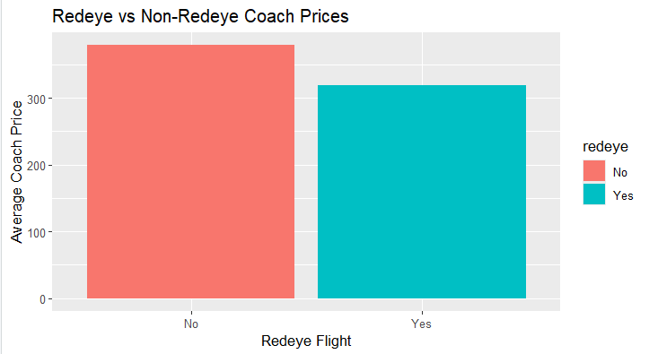
Interpretation
Redeye flights are often cheaper because they operate during late-night hours.

##Q10: Perform the analysis for appropriate variables
Solution :
#Summary statistics
summary(flight_sample)
Output
miles passengers delay
Min. : 260 Min. :141.0 Min. : 0.00
1st Qu. :1340 1st Qu.:204.0 1st Qu.: 9.00
Median :1978 Median :210.0 Median : 10.00
Mean :2001 Mean :207.6 Mean : 13.29
3rd Qu. :2468 3rd Qu.:215.0 3rd Qu.: 13.00
Max. :4545 Max. :244.0 Max. :1528.00
inflight_meal inflight_entertainment inflight_wifi
Length:10000 Length:10000 Length:10000
Class :character Class :character Class :character
Mode :character Mode :character Mode :character

day_of_week redeye weekend
Length:10000 Length:10000 Length:10000
Class :character Class :character Class :character
Mode :character Mode :character Mode :character

coach_price firstclass_price hours
Min. : 84.5 Min. : 970.7 Min. :1.000
1st Qu.:331.3 1st Qu.:1300.6 1st Qu.:2.000
Median :380.3 Median :1501.2 Median :4.000
Mean :376.0 Mean :1453.7 Mean :3.622
3rd Qu.:426.4 3rd Qu.:1581.8 3rd Qu.:4.000
Max. :586.0 Max. :1812.7 Max. :8.000

#(b) Visualization
library(ggplot2)
# Histogram
ggplot(flight_sample,
aes(x=coach_price)) +
geom_histogram(bins=30)
Output
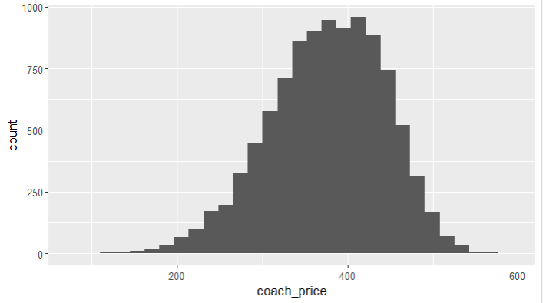

# Boxplot
ggplot(flight_sample,
aes(y=coach_price)) +
geom_boxplot()
Output
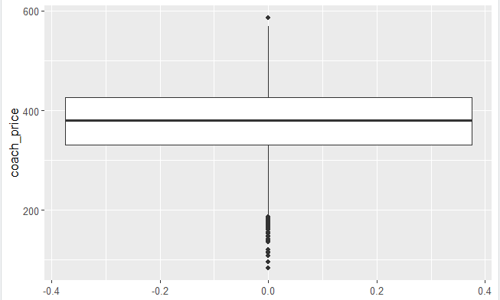
# Bar chart
ggplot(flight_sample,
aes(x=weekend)) +
geom_bar()
Output
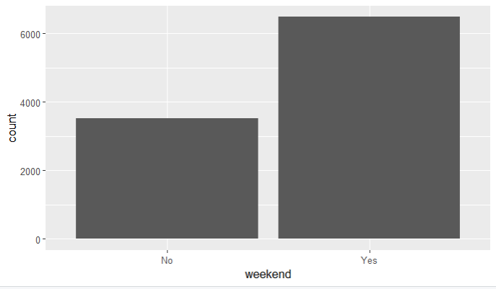

##(c) Hypothesis Testing (Independent t-test)
t.test(
coach_price ~ weekend,
data=flight_sample
)
Output
Welch Two Sample t-test

data: coach_price by weekend
t = -73.684, df = 7064.8, p-value <
2.2e-16
alternative hypothesis: true difference in means between group No and group Yes is not equal to 0
95 percent confidence interval:
-87.21771 -82.69724
sample estimates:
mean in group No mean in group Yes
320.8771 405.8346

##(d) Correlation Analysis
cor(
flight_sample[, c(
"coach_price",
"miles",
"hours",
"delay",
"firstclass_price"
)]
)
Output
coach_price miles
coach_price 1.0000000 0.342708985
miles 0.3427090 1.000000000
hours 0.3371431 0.985211774
delay -0.0153009 -0.005755326
firstclass_price 0.7625297 0.295900806
hours delay
coach_price 0.33714307 -0.015300901
miles 0.98521177 -0.005755326
hours 1.00000000 -0.004757490
delay -0.00475749 1.000000000
firstclass_price 0.29146142 -0.025528080
firstclass_price
coach_price 0.76252966
miles 0.29590081
hours 0.29146142
delay -0.02552808
firstclass_price 1.00000000

##(e) Linear Regression
model <- lm(
coach_price ~ miles + hours + delay,
data=flight_sample
)
summary(model)
Output
Call:
lm(formula = coach_price ~ miles + hours + delay, data = flight_sample)

Residuals:
Min 1Q Median 3Q Max
-287.736 -42.123 4.627 49.941 178.604

Coefficients:
Estimate Std. Error t value
(Intercept) 326.852093 1.512646 216.080
miles 0.025869 0.003952 6.546
hours -0.647266 2.145323 -0.302
delay -0.021212 0.014969 -1.417
Pr(>|t|)
(Intercept) < 2e-16 ***
miles 6.21e-11 ***
hours 0.763
delay 0.157
---
Signif. codes:
0 ‘***’ 0.001 ‘**’ 0.01 ‘*’ 0.05 ‘.’ 0.1 ‘ ’ 1

Residual standard error: 63.95 on 9996 degrees of freedom
Multiple R-squared: 0.1176, Adjusted R-squared: 0.1174
F-statistic: 444.2 on 3 and 9996 DF, p-value: < 2.2e-16

#10(f) Logistic Regression
flight_sample$redeye_binary <-
ifelse(
flight_sample$redeye=="Yes",
1,0
)

log_model <- glm(
redeye_binary ~ hours + coach_price,
data=flight_sample,
family="binomial"
)
summary(log_model)
Output
Call:

glm(formula = redeye_binary ~ hours + coach_price, family = "binomial",
data = flight_sample)

Coefficients:
Estimate Std. Error z value
(Intercept) 1.2025056 0.2130049 5.645
hours 0.2716457 0.0276520 9.824
coach_price -0.0144507 0.0006844 -21.114
Pr(>|z|)
(Intercept) 1.65e-08 ***
hours < 2e-16 ***
coach_price < 2e-16 ***
---
Signif. codes:
0 ‘***’ 0.001 ‘**’ 0.01 ‘*’ 0.05 ‘.’ 0.1 ‘ ’ 1

(Dispersion parameter for binomial family taken to be 1)

Null deviance: 4254.0 on 9999 degrees of freedom
Residual deviance: 3767.7 on 9997 degrees of freedom
AIC: 3773.7

Number of Fisher Scoring iterations: 6

Conclusion

This analysis explored several important aspects of airline ticket pricing and flight charac teristics using R programming. The study identified relationships between ticket prices, distance, flight duration, delays, and additional flight services. Statistical analysis and visualization techniques helped provide meaningful insights into airline pricing patterns.

References
- RProgramming Documentation
- ggplot2 Package Documentation
- dplyr Package Documentation

